**Health & Safety Talk**

Toolbox Talk

**Manual Handling** 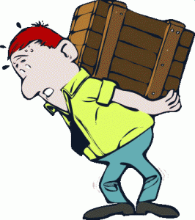

In the metal scraping industry most of WorkCover claims are a result of manual handling injuries. Manual handling includes but is not limited to:

Lifting Twisting Lowering Holding

Pushing Reaching upwards Throwing Assembling

Pulling Stretching Carrying Reaching low

To identify hazardous manual handling from the tasks above, the factors need to be considered:

Weight of the object Awkward object and postures Environmental factors High forces applied Overreaching Duration and frequency

**What are the risks?**

Musculoskeletal disorders/injures (e.g. back pain, muscle sprains and strains, soft tissue injuries, fractures and dislocations, abdominal hernias, carpel tunnel syndrome and tendonitis)

**What should be done?**

* Avoid lifting if it is reasonably practicable to do so.
* Use the correct procedures (e.g. bend the knees not the back) when performing manual handling tasks.
* Use mechanical aids to lift, hold or transport such as trolleys, engine cranes, transmission jacks, gantry cranes, etc.
* Break down heavy loads into smaller quantities.
* If you can’t do any of the above, call for assistance and perform a team lift.

|  |  |
| --- | --- |
| **Consultation** |  |

**Date of Meeting:**_____________________

**Attendees** (list attendees present)

|  |
| --- |
|  |

**Items Discussed**

|  |
| --- |
|  |

**Action Items**

|  |
| --- |
|  |

**Management Sign Off**

**Name:** _______________________________________

**Sign:** ___________________________________ **Date:** ______________________________